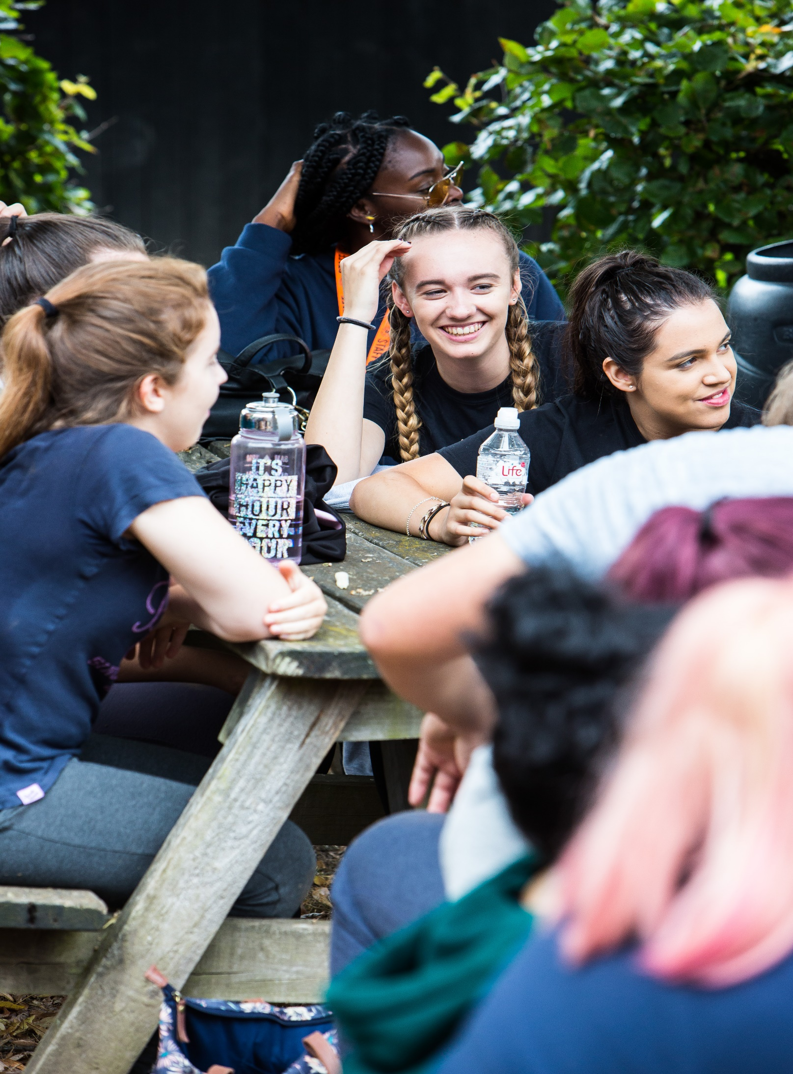

AN INTRODUCTION TO: VOLUNTEERING AND SOCIAL ACTION
@INGEUSYOUTH

Introduction

At NCS, we are passionate about young people using their voices for good. Every year, thousands of students spend their summer with us raising money and awareness for charities of their choosing, as a part of the ‘Do Good’ phase of our NCS Programme. We have put together this pack of activities to get young people thinking about what they are passionate about, how they can help those in need and what volunteering options are out there for them. This guide will lay out the activities and how to access them.

The Activities

In the Volunteering and Social Action Folder you will find worksheets and mark sheets (where applicable) for each of the activities below:

- Crack the Anagrams! (10 Minutes)
- Charity wordsearch (20-25 minutes)
- A-Z Volunteering worksheet (15 minutes)
- Historical Social Justice Movements Quiz (20-25 minutes)
- How Volunteering Can Help Your Career Goals – Booklet (20-25 minutes)
*Hold CTRL and click the link inside the activity documents.
Useful Video Resources:

Careers and Volunteering: Clink here to show a short video about the benefits of volunteering for young people and their Career Goals.

